**Basic Website using Node JS, Express JS, MongoDB**

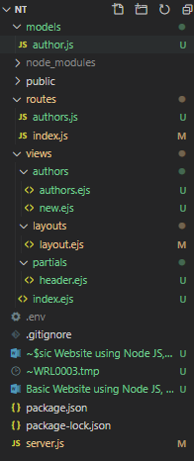

M – Models

V – Views

C – Controller (routes)

Models : author.js :- usually this is in singular form of our routes : authors.js

Express has no easy way to access variables..hence we have to install library

Cmd : npm i body-parser

 

package.json

{

  "name": "NT",

  "version": "1.0.0",

  "description": "",

  "main": "server.js",

  "scripts": {

    "start": "node server.js",

    "devStart": "nodemon server.js"

  },

  "keywords": [],

  "author": "",

  "license": "ISC",

  "dependencies": {

    "ejs": "^3.1.3",

    "express": "^4.17.1",

    "express-ejs-layouts": "^2.5.0",

    "kill-port": "^1.6.1",

    "mongoose": "^5.9.25"

  },

  "devDependencies": {

    "dotenv": "^8.2.0",

    "nodemon": "^2.0.4"

  }

}

server.js

if (process.env.NODE_ENV !== 'production') {

  require('dotenv').load()

}

const express = require('express')

const app = express()

const expressLayouts = require('express-ejs-layouts')

const indexRouter = require('./routes/index')

app.set('view engine', 'ejs')

app.set('views', __dirname + '/views')

app.set('layout', 'layouts/layout')

app.use(expressLayouts)

app.use(express.static('public'))

const mongoose = require('mongoose')

mongoose.connect(process.env.DATABASE_URL, { useUnifiedTopology: true,  useNewUrlParser: true,})

const db = mongoose.connection

db.on('error', error => console.error(error))

db.once('open', () => console.log('Connected to Mongoose'))

app.use('/', indexRouter)

app.listen(process.env.PORT || 3000)

index.js in Routes folder (Controller)

const express = require('express')

const router = express.Router()

router.get('/', (req, res) => {

    res.render('first')

})

module.exports = router

<https://mybrary5403.herokuapp.com/>

<https://www.youtube.com/playlist?list=PLZlA0Gpn_vH8jbFkBjOuFjhxANC63OmXM>

<https://github.com/WebDevSimplified/Mybrary/tree/v1.0>

<https://dashboard.heroku.com/>

**m**

**m**